**Use Cases:**

**#1:**

|  |  |
| --- | --- |
| Name | Child user logs in to play games |
| Description | After logging in, child user is able to play math games to refine their math skills while encouraging them to go outdoors through the use of an ingame points system that lets them utilize those points in amusement parks. |
| Actors | Children |
| Organizational Benefits | Help middle school students get better at math and go outside |
| Triggers | The user logs in |
| Preconditions | User is views list of games |
| Postconditions | The user played a math game, refined math skills, and is motivated to go outside. |
| Main course | 1. Prompt the child user to login 2. User is prompted to choose a game to play 3. User plays game 4. User gains points in the game that they can potentially redeem in the amusement park. |
| Alternate Courses | AC1 Website determines user is already logged in:   * See Main Course #2   AC2 Website determines that user logs off:   * See Main Course #1   AC3 Website determines that the user does not already have an account:   1. User is prompted to create an account 2. Account creation is confirmed 3. See Main Course #1-#4   AC4 System recognizes that the user is not a child user:   1. If user is a parent user, see use case #2 2. If user is a school administrator, see use case #3 |
| Exceptions | EX1 The website fails to save a child’s data:   1. The system will notify the user that an error occurred 2. See Main Course #1   EX2 The user does not want to create an account:   1. User must create an account to play the games |

**#2:**

|  |  |
| --- | --- |
| Name | Child user’s parent logs in to monitor child |
| Description | The parent is able to see their child’s progress/data on the site. |
| Actors | Parents |
| Organizational Benefits | Allow parents to monitor what their kids do on the site to reassure parents the site is safe and beneficial. |
| Triggers | Parent wants to see what their kids are playing/doing on the site |
| Preconditions | Parent logs in |
| Postconditions | Parent is able to view their child’s activities on the site |
| Main Course | 1. Prompt user to login 2. Prompt user to look at child’s activity 3. Parent user sees a feed of their child’s recent activities |
| Alternate Course | AC1 Website determines user is already logged in:   * See Main Course #2   AC2 Website determines that user logs off:   * See Main Course #1   AC3 Website determines that the user does not already have an account:   1. User is prompted to create an account 2. Account creation is confirmed 3. User is prompted to link their account to their kids 4. See Main Course #1-#3   AC4 System recognizes that the user is not a parent user:   1. If user is a child user, see use case #1 2. If user is a school administrator, see use case #3 |
| Exceptions | EX1 The website fails to show a child’s data to parent:   1. The system will notify the user that an error occurred 2. See Main Course #1 |

**#3:**

|  |  |
| --- | --- |
| Name | School administrator logs in to monitor children |
| Description | School administrator is able to see kids’ progress/data that are enrolled in their school and have accounts on the site. |
| Actors | School administrator |
| Organizational Benefits | Since schools are also responsible for kids besides parents, giving the school administrator access to kids’ data can reassure parents even more by showing them that their child’s school is helping them monitor their kids in order to ensure a safe, healthy, and beneficial usage of the site. |
| Triggers | School administrator wants to see what their school’s kids are doing on the site |
| Preconditions | School administrator logs in |
| Postconditions | School administrator is able to see the activities of all the kids that go to their school and have accounts on the site. |
| Main Course | 1. School administrator is prompted to login 2. School administrator is prompted to view kids’ activities 3. School administrator is shown a list of all kids that they can monitor 4. School administrator chooses which child user to monitor and looks at their activity on the site. |
| Alternate Course | AC1 Website determines user is already logged in:   * See Main Course #3   AC2 Website determines that user logs off:   * See Main Course #1   AC3 Website determines that the user does not already have an account:   1. User is prompted to create an account 2. Account creation is confirmed 3. User is prompted to link their account to the kids that go to their school 4. See Main Course #1-#4   AC4 System recognizes that the user is not a school administrator:   1. If user is a child user, see use case #1 2. If user is a parent user, see use case #2 |
| Exceptions | EX1 The website fails to show a child’s data to school administrator:   1. The system will notify the user that an error occurred 2. See Main Course #1 |

**Sequence Diagrams:**

**#1:**

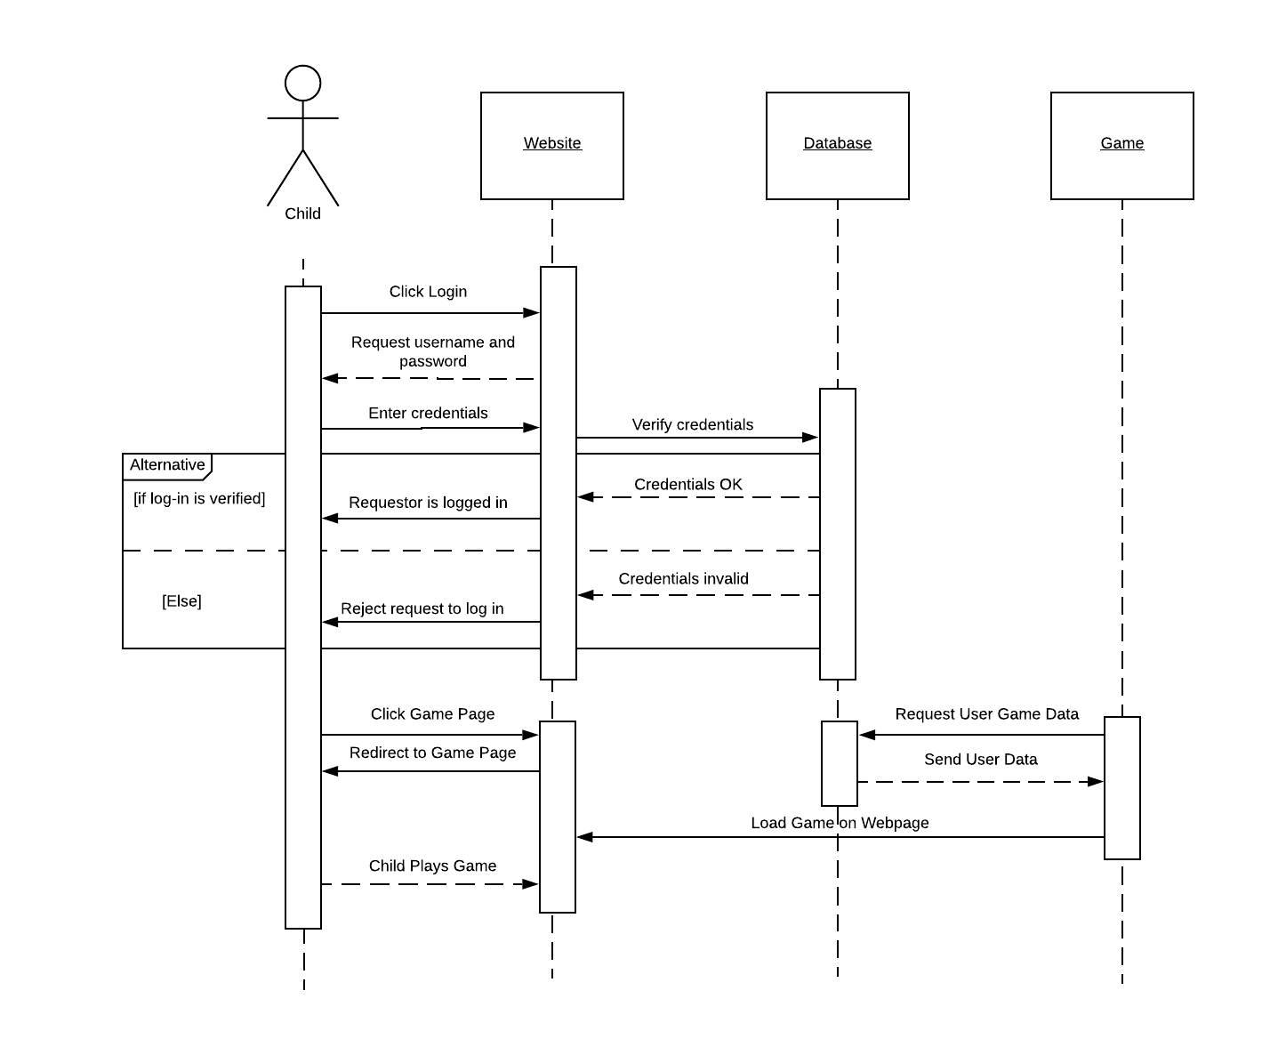

**#2:**

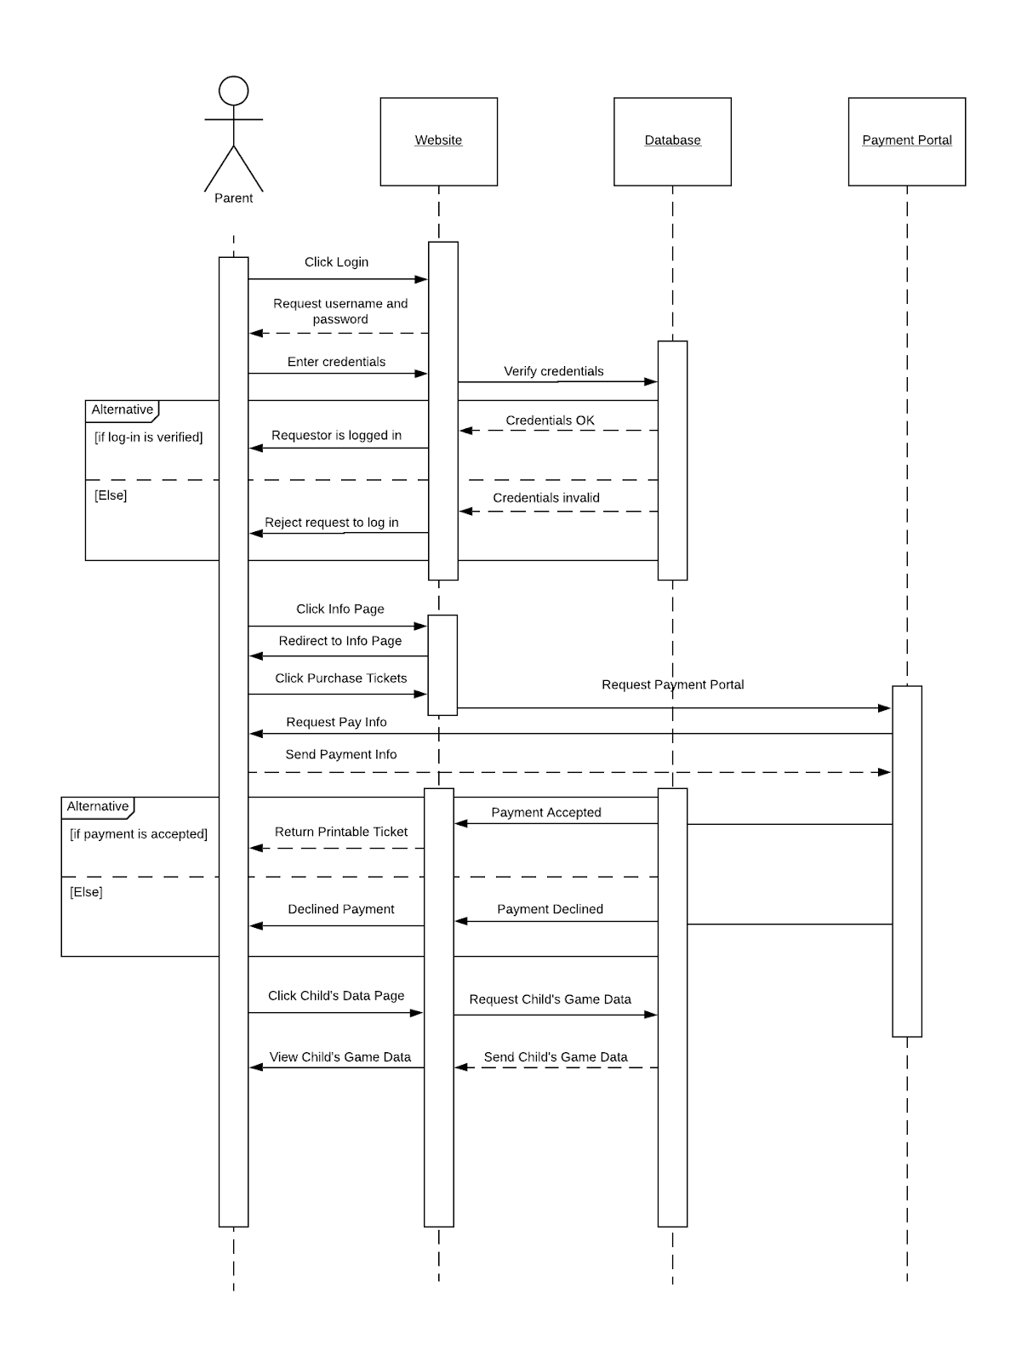

**#3:**

